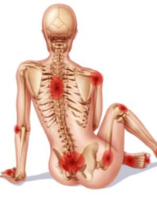


Msk?...Think SpA! Recognition and referral of Axial and Peripheral Spondyloarthritis
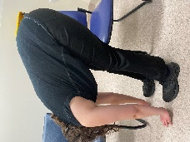


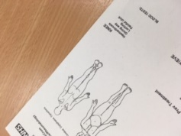


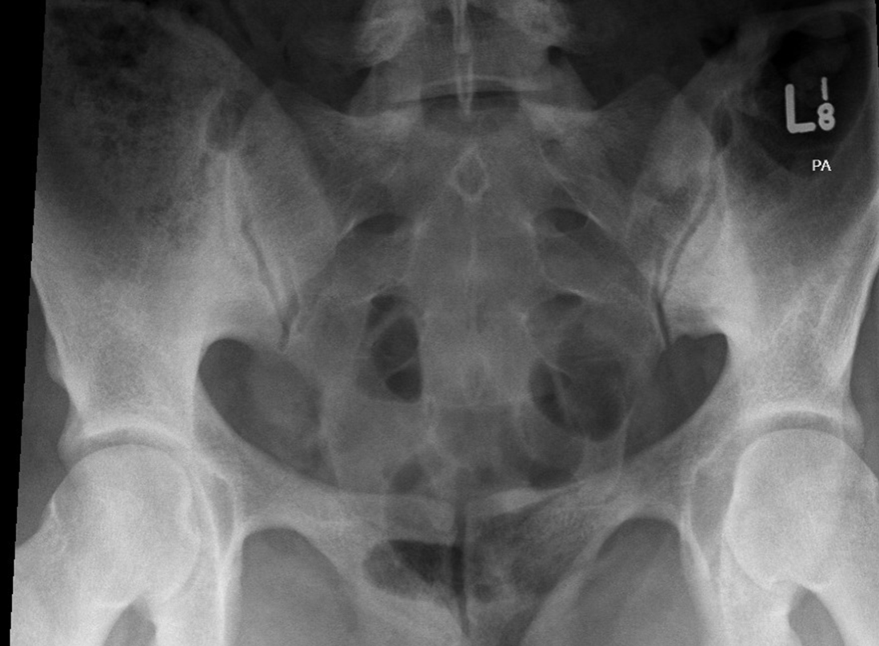

Are you a musculoskeletal clinician ready to sharpen up your diagnostic skills—all in a single day?
Join our interactive online workshop designed to help you confidently recognise and refer suspected cases of axial and peripheral Spondyloarthritis (SpA). The course covers these commonly unrecognised conditions, including psoriatic arthritis (PsA) and enteropathic inflammatory arthritis

🔍 Why This Matters
Spondyloarthritis (SpA) often masquerades as common musculoskeletal issues—leading to diagnostic delays of up to 9 years. Early recognition is critical, and you are the key to unlocking better outcomes.

💡 What You’ll Learn
- How to spot clinical flags for axial and peripheral spondyloarthritis
- When and how to refer to Rheumatology for timely intervention
- Clinical features that distinguish inflammatory from mechanical pain
- The latest insights on imaging, screening, and referral pathways

🚀 Outcome
Empower your practice with the skills to:
- Reduce diagnostic delays
- Improve patient outcomes
- Support earlier access to life-changing treatments

🗓️ Don’t Miss Out
Be part of the movement to close the diagnostic gap and elevate your clinical impact.

Targeted health professional education: for musculoskeletal clinicians assessing and managing people presenting with back pain and peripheral joint and tendon problems:

Target participants: Healthcare Practitioners in primary care: Musculoskeletal Physiotherapists, Osteopaths, General Practitioners

Education workshop series:
Aim- To raise awareness and develop knowledge and clinical skills in musculoskeletal clinicians on how to recognise and when to refer to Rheumatology for suspected axial spondyloarthritis (Axial SpA) peripheral spondyloarthritis (SpA) and common diseases such as Psoriatic Arthritis (PsA)

Outcome:
Improving delays to diagnosis of Axial Spondyloarthritis and Psoriatic Arthritis by improving recognition and referral of suspected axial and peripheral spondyloarthritis by primary care clinicians to support earlier diagnosis, intervention and improved outcomes.
Background:
Spondyloarthritis is a group of inflammatory conditions that mimic common musculoskeletal problems. Delays in diagnosis average up to 8-9 years for many people, despite significant advances in research and imaging¹, because it is often not recognised in musculoskeletal assessments ^{2,3}. Screening for suspected spondyloarthritis (SpA) and when to refer onto rheumatology is an essential a core skill in clinical assessments ^{4,5}.
Musculoskeletal clinicians are key to early diagnosis to help reduce the significant immediate and long-term impacts of these inflammatory diseases. Spondyloarthritis can be challenging to recognise and often mistaken as chronic mechanical low back pain or unrelated tendon and joint problems^{4,5}. Research shows that the inflammatory disease links between persistent back pain, peripheral problems and extra-articular inflammatory manifestations are often missed in clinical practice². Knowing what features should raise suspicion of spondyloarthritis and when to refer onto rheumatology is an important aspect of musculoskeletal clinical practice, along with a multidisciplinary team approach to management. Research also indicates that musculoskeletal clinicians report a lack confidence and awareness in screening for axial spondyloarthritis^{3, 6}, added to by findings of a paucity of literature on axial SpA and PsA occurring in musculoskeletal professional literature^{7.}
NICE Guidance has developed clinical guidance to support earlier recognition, diagnosis, treatment and other important considerations in people diagnosed with SpA. This is supported by increasing research, national campaigns and the development of increasing resources to support earlier diagnosis^{8,9}. This course aims to enable clinicians to develop their clinical knowledge and skills to screen for suspected spondyloarthritis within musculoskeletal assessments and when to refer for Rheumatology assessment, and to raise awareness of the research and resources available to support their clinical practice in screening for these conditions.
References
1.Gregory WJ, Kaur J, Bamford S, Tahir H. A Survey of Diagnostic Delay in Axial Spondyloarthritis Across Two National Health Service (NHS) Rheumatology Services. Cureus. 2022 Mar 30;14(3):e23670. doi: 10.7759/cureus.23670. PMID: 35510018; PMCID: PMC9060761.
2. McCrum, C., Kenyon, K., Cleaton, J. and Dudley, T., (2019). An Unrecognised Masquerader: a retrospective review of people presenting to musculoskeletal physiotherapy with undiagnosed spondyloarthritis. Physiotherapy, 105, e102-e103.
3. Steen, E. Cairns, M., McCrum, C (2021). Physiotherapist’ awareness, knowledge and confidence in screening and referral of suspected Spondyloarthritis: A survey of UK clinical practice. Musculoskeletal Care, Feb https://doi.org/10.1002/msc.1537
4.McCrum C (2019) Appraisal of Clinical Practice Guideline: NICE Guidance on Spondyloarthritis in over 16s: diagnosis and management [NG65], Journal of Physiotherapy, 65, 4, 242. doi.org/10.1016/j.jphys.2019.07.001
5.McCrum (2019) Guest Editorial -When to suspect spondyloarthritis: A core skill in musculoskeletal clinical practice. Musculoskeletal Science and Practice, 41, iii. https://doi.org/10.1016/j.msksp.2019.102079
6. Yong CY, Hamilton J, Benepal J, Griffiths K, Clark ZE, Rush A, Sengupta R, Martindale J, Gaffney K. Awareness of axial spondyloarthritis among chiropractors and osteopaths: findings from a UK Web-based survey. Rheumatol Adv Pract. 2019 Sep 30;3(2):rkz034. doi: 10.1093/rap/rkz034. PMID: 31616854; PMCID: PMC6785804.
7. McCrum, C. 2020. Delaying Diagnosis: inflammatory back pain and other features of suspected spondyloarthritis have been rarely featured in musculoskeletal health professions literature, British Society of Rheumatology, 22 April. Supp_2
8.MacMillan, A, Corser, A, Clark, Z, McCrum, C, Gaffney, K (2021) Masterclass: Axial spondyloarthritis for osteopaths and manual therapists. International Journal of Osteopathic Medicine, 41. pp. 45-56. ISSN 1746-0689
9.Rheumatology_Physiotherapy_Capabilities_Framework_vFINAL_Interactive.pdf (macpweb.org)

Learning outcomes
- Develop an awareness of the clinical presentations of axial spondyloarthritis and peripheral spondyloarthropathies.
- Gain an understanding of the importance of screening for spondyloarthritis in musculoskeletal clinical assessments.
- Develop knowledge of the clinical signs, symptoms and risk factors which increase suspicion of axial and peripheral spondyloarthritis.
- Gain knowledge and skills in screening for axial and peripheral spondyloarthritis in a clinical examination.
- Develop an understanding of the recommendations of NICE Guidance on Spondyloarthritis on when to refer to rheumatology and discussion on how to undertake referrals.
- Develop an understanding of the role of blood tests and imaging in suspected axial and peripheral spondyloarthritis.
- Gain practical skills in history taking and clinical examination for suspected spondyloarthritis and associated extra-articular manifestations, including skin and nail examination for psoriasis.
- Be aware of features and develop advanced clinical reasoning skills in the differentiation of mechanical and suspected inflammatory clinical presentations.
- Develop an awareness of treatment options for spondyloarthritis and supporting long-term management.

Learning outcomes | Delivery Methods | Msk CCF ^ | IFOMPT Dimension# | FCP Roadmap Essential Knowledge: Specific knowledge underpinning capabilities 1 & 2
- Develop an awareness of the clinical presentations of axial spondyloarthritis and peripheral spondyloarthropathies. | - Clinical reasoning through vignette cases and knowledge quizzes  - Pre-course reading and resource materials  - Peer learning through questions, group activities and discussion | - B3, B4, B5 | - D2, D5, D6, D8,  - K1, K2, K3, K4, K5, K7  - S3  - D1-S3  - D4- K3 | - D1-K1, S1,2,3 A1
- Gain an understanding of the importance of screening for spondyloarthritis in musculoskeletal clinical assessments. | - Interactive Lectures  - Pre-course reading and resource materials  - Reflective learning with pre- & post knowledge evaluation | - B3, B4, B5 | - D2, D6, K5, K1, K11 | - D1-K1, S3  - D5-K8, K9
- Develop knowledge of the clinical signs, symptoms and risk factors which increase suspicion of axial and peripheral spondyloarthritis. | - Clinical reasoning through vignette cases  - Group knowledge quizzes and discussionss  - Pre-course reading and resource materials  - Peer learning through questions, group activities and discussion | - B3, B4, B5 | - D2, D5, D6, D8,  - K1, K2, K3, K4, K5, K7  - D9-S1, A2
- Gain knowledge and skills in screening for axial and peripheral spondyloarthritis in a clinical examination. | - Clinical reasoning through vignette cases and knowledge quizzes  - Pre-course reading and resource materials  - Peer learning through questions, group activities and discussion | - A1, B3, B4, B5 | - D3, D5, D6,D7, K3, S1, S9  - D6-S3 | - D1-K1, S1,2,3 A1  - D2- K1,K2,K5, K7, K8, K9  - D3-K1, K3, K4, S2, A1  - D5- K8, K9  - D10-K2, K3, K5, S5
- Develop an understanding of the recommendations of NICE Guidance on Spondyloarthritis on when to refer to rheumatology and discussion on how to undertake referrals. | - Clinical reasoning through vignette cases  - Group knowledge quizzes and discussions  - Pre-course reading and resource materials  - Peer learning through questions, group activities and discussion | - B3, B4, B5 | - D2, D5, D6, D10, K5, K9 | - D2- S1, S3, A1, A2, A3  - D3  - D4-K4,  - D7- K3,K4  - D8-K4  - D10-S3,
- Develop an understanding of the role of blood tests and imaging in suspected axial and peripheral spondyloarthritis. | - Interactive lectures  - Clinical reasoning through vignette cases  - Group knowledge quizzes and discussions  - Pre-course reading and resource materials  - Peer learning through questions, group activities and discussion | - B3, B4, B5 | - D2, D4, D5, K3, K5, K9  - D5-K9 | - D1-K1, S1, S3  - D5-K8, K9
- Gain practical skills in history taking and clinical examination for suspected spondyloarthritis and associated extra-articular manifestations, including skin and nail examination for psoriasis. | - Clinical reasoning through vignette cases  - Group practical activities  - knowledge quizzes and discussions  - Pre-course reading and resource materials  - Peer learning through questions, practice and discussion | - B3, B4, B5, C6, C7, C12, C13 | - D3, K4  - D2-S1  - D3-S1  - D4-S1 | - D1-K1, S1,2,3 A1  - D2- K1,K2,K5, K11, K12, K13, S1, S2, S3  - D5-K2, S1, S2, A2  - D6—K2, K3,K4, K5  - D8-K1, K3, K4, S2, A1, A2  - D10 K1, A5
- Be aware of features and develop advanced clinical reasoning skills in the differentiation of mechanical and suspected inflammatory clinical presentations. | - Interactive lectures  - Clinical reasoning through vignette cases  - Group knowledge quizzes and discussions  - Peer learning through questions, group activities and discussion |  | - D2 K5 | - D1-K1, K2, K5, S1,2,3 A1  - D2- K1,K2,K5, K7, K8, K9  - D3 Critical use of a comprehensive knowledge base of the clinical sciences in the speciality of OMT: K1, K3, K4, S2  - D5-K2, K8, K9  - D6-A1, A3, A4, A5
- Develop an awareness of other considerations with Spondyloarthritis | - Interactive lectures  - Pre-course reading and resource materials | - B3, B4, B5, | - D2, D4, D5, K3, K5, K9  - D5-K9 | - Domain C: Condition management, interventions and prevention  - D8-K2
- Develop an awareness of professional support resources for recognition and referral of axial spondyloarthritis | - Interactive lectures and discussions  - Course reading, handouts and resource materials | B3, B4, B5, | D2 K5  D6- A2, | D7-K3, K4,
Speaker:
The Education workshops will be delivered by Dr Carol McCrum (B.Sci.App., GD (Manip), Dip Inj, Dip Msk.Med (RCP Edin.), DPT, UK Non-medical Prescriber). Carol is Consultant Physiotherapist, Advanced Practice Rheumatology Physiotherapist and NICE Fellow who has successfully delivered this series of workshops in the UK to Physiotherapists, osteopaths and GPs since 2018 to support earlier diagnosis and reduce the impacts for people with axial and peripheral spondyloarthritis and other
Biography
Dr Carol McCrum has been a Consultant Physiotherapist in Rheumatology and Orthopaedics since 2005 and currently works at Canberra Hospital, Rheumatology Department, ACT. Carol completed her doctorate in acute low back pain (2011) and is a Visiting Research Fellow at University of Brighton, and an affiliate member University of Canberra Musculoskeletal Research Interest Group. She remains active in research, publication and knowledge translation, and supports researcher development in clinical and academic contexts.

Carol was a committee member of NICE Guidance (2017) and Quality Standards (2018) on Spondyloarthritis and was awarded a NICE Fellowship to raise awareness of this guidance. She is involved in national and international projects to improve pathways, develop guidance and promote high quality care in rheumatology, including membership of the WHO RA Rehabilitation guidance development group and the Axial Spondyloarthritis All Party Parliamentary Group championing earlier diagnosis and care. Carol is a member of the BSR Physiotherapy Working Group, APA RHPA and Co-Chair of the recently formed Rheumatology Specialist Physiotherapy Clinical Interest Group. She is co-author of the UK Rheumatology Physiotherapy Capabilities Framework development project. The Capabilities Framework aims to support the physiotherapy workforce, role development, professional education, and support those working in musculoskeletal clinical practice to ensure early recognition and referral of suspected rheumatological conditions.

Proposed timetable
09:00 - 09:15 – Arrivals and welcome
09:15 -09:45 - Msk?...Think SpA! Overview of Axial Spondyloarthritis (AxSpA) and Psoriatic Arthritis (PsA) and clinical manifestations
09:45 - 10:30 When to suspect axial and peripheral spondyloarthritis -NICE clinical guidance on referral to rheumatology

10:30 – 10:45 Break

10:45- 11.15 - Imaging considerations in suspected axSpA and Psoriatic Arthritis/Peripheral SpA
11:15 - 11:30 Other considerations in people with spondyloarthritis
11:30 - 12:00 Extra-articular manifestations- considerations for clinical assessments

12:00 - 12:30 Lunch

12:30 - 13:00 Screening - History taking, case studies and clinical reasoning workshop- practical workshop
13:00 - 14:00 Extra-articular manifestations – considerations, clinical assessments and skin examination – practical workshop
14:00 - 14:15 Referral letters and pathways- discussion and Q&A
14:15- 14:30 Summary, final questions and feedback questionnaires

Course suitability
This course is suitable for clinicians involved in the assessment and management of musculoskeletal conditions in daily practice, particularly those managing persistent back pain and peripheral joint and tendon problems. It is also suitable for University and clinical educators involved in pre and post graduate professional education of musculoskeletal assessment and management.

Number of participants- 20-25 per venue (30 maximum)

